Week 4 Day01 Assignment
Fine tuning the model
- Configuring the input and output path in TrainingDataConvertor.java file
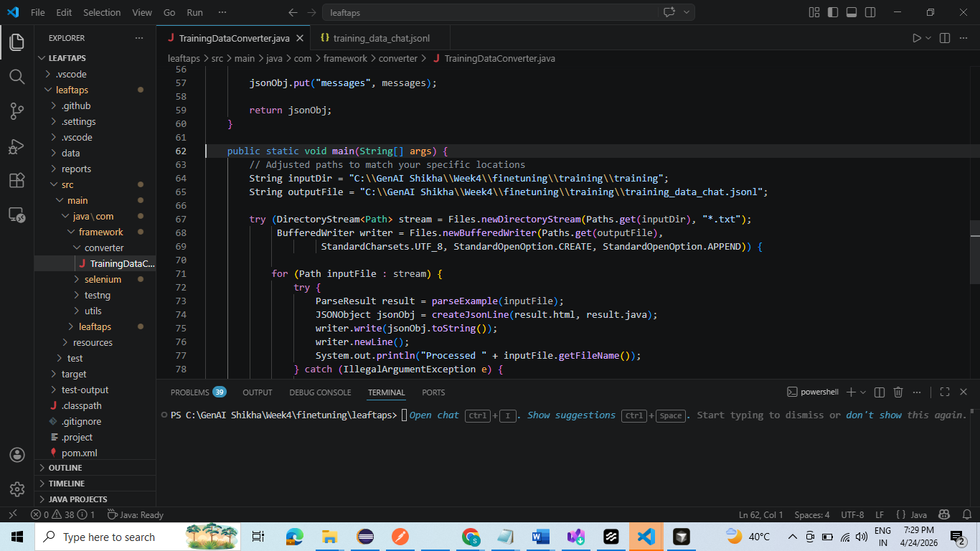
- Execute TrainingDataConvertor.java file and JSONL file will be stored in the specified output location
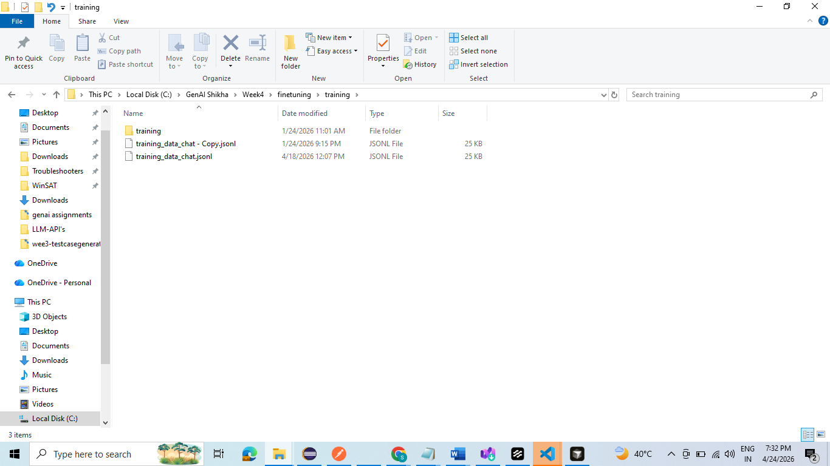
JSONL File
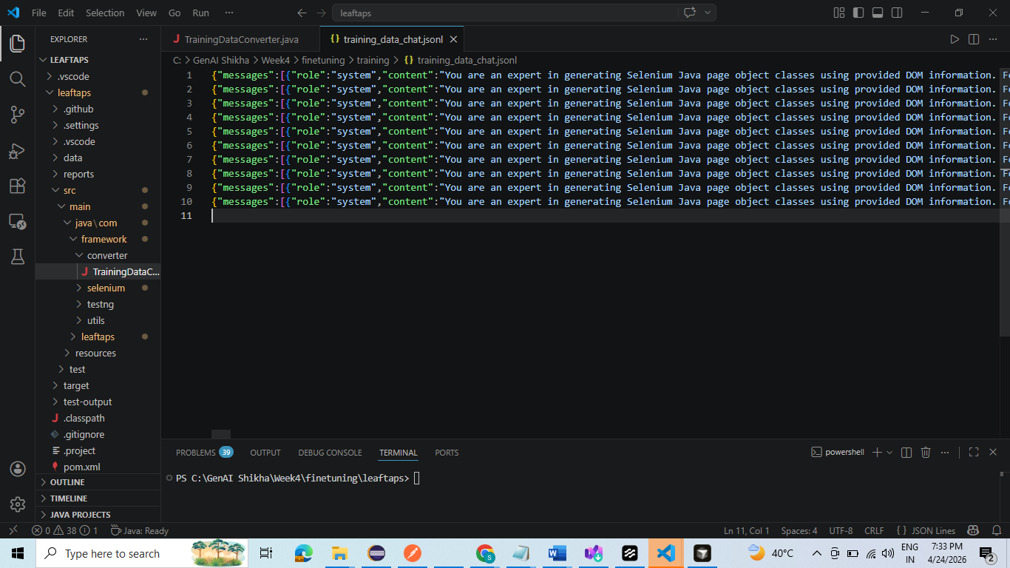
3. Successful Creation of Finetuned model
